STAT 3232

Quiz 03

212137

1. .
2. > boxplot(Sepal.Length~Species)

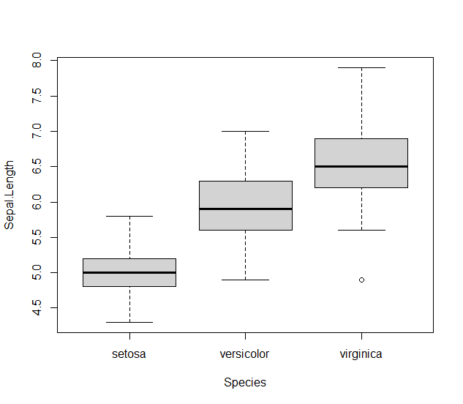

1. > pie(table(Species))

